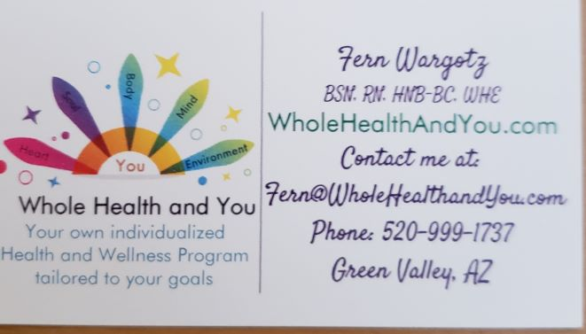

Whole Health and You Disclaimer
Whole Health Educators and Holistic Nurses are NOT Medical Doctors (MDs). Whole Health Educators and Holistic Nurses are trained specialists who use non-invasive holistic practices to Educate, advocate and share evidenced based information so that you, the Client, can make educated decisions for your health and wellness.

I authorize Whole Health and You, Fern Wargotz WHE, RN, BSN, HNB-BC, to perform services to develop a natural, complementary health improvement program for me in order to assist me in improving my overall health and not for the treatment or “cure” of any disease.
I understand that the services rendered are safe, non-invasive holistic methods of balancing the body’s physical, emotional, and nutritional needs and those imbalances can cause or contribute to various health problems.
I understand that I should continue to see any medical doctors I am currently under the care of, and that any prescription medication should not be altered without first consulting the Doctor who recommended it
Nothing said, done, typed, printed or reproduced by Whole Health and You, Fern Wargotz WHE, RN, BSN, HNB-BC is intended to diagnose, prescribe, treat or take the place of a licensed physician.
I am a willing participant in Whole Health and You, Fern Wargotz WHE, BSN, HNB-BC, Whole Health Education Program and when chosen; Aura Photography for educational and self-knowledge purposes.
I understand Whole Health and You, Fern Wargotz WHE, RN. BSN, HNB- BC is a facilitator of Whole Health Education.
I will act with integrity by being on time, clean, properly dressed, and respectful in sessions.
I will demonstrate the appropriate behavior for the safety of everyone.
I will not attend any provider sessions while under the influence of drugs or alcohol.
I understand that Whole Health and You, Fern Wargotz WHE, RN, HNB-BC, BSN is not liable for my healthcare.
I understand that if I do not abide by these guidelines I will be removed from the program.
In consideration for receiving permission to participate in Whole Health and You, Fern Wargotz WHE RN, BSN, HNB-BC I hereby RELEASE, WAIVE, DISCHARGE, AND COVENANT NOT TO SUE Whole Health and You, Fern Wargotz WHE, RN, BSN, HNB- BC, from any and all liability, claims, demands, actions, and causes of action whatsoever arising out of or related to any loss, damage, or injury, including death, that may be sustained by me, or to any property belonging to me, while participating in such activity, while in, on or upon the premises where the activities are being conducted, REGARDLESS OF WHETHER SUCH LOSS IS CAUSED BY THE NEGLIGENCE OF THE RELEASEES, or otherwise and regardless of whether such liability arises in tort, contract, strict liability, or otherwise, to the fullest extent allowed by law.
I am fully aware of the risks and hazards connected with the activities of Whole Health Education, treatments and practices and I am aware that such activities include the risk of injury and even death, and I hereby elect to voluntarily participate in said activities, knowing that the activities may be hazardous to my body and my property. I understand that Whole Health and You, Fern Wargotz WHE, RN, BSN, HNB- BC does not require me to participate in these activities. I voluntarily assume full responsibility for any risks of loss, property damage, or personal injury, including death, that may be sustained by me, or any loss or damage to property owned by me, as a result of being engaged in such activities, WHETHER CAUSED BY THE NEGLIGENCE OF RELEASEES or otherwise, to the fullest extent allowed by law. I further hereby agree to INDEMNIFY AND HOLD HARMLESS the RELEASEES from any loss, liability, damage, or costs, including court costs and attorney’s fees that Releasees may incur due to my participation in said activities, WHETHER CAUSED BY THE NEGLIGENCE OF RELEASEES or otherwise, to the fullest extent allowed by law.
It is my express intent that this Waiver and Hold Harmless Agreement shall bind the members of my family and spouse, if I am alive, and my heirs, assignees and personal representative(s), if I am deceased, and shall be deemed as a RELEASE, WAIVER, DISCHARGE, AND COVENANT NOT TO SUE the above-named Releasees. I hereby further agree that this Waiver of Liability and Hold Harmless Agreement shall be construed in accordance with the laws of the State of Arizona and that any mediation, suit, or other proceeding must be filed or entered into only in Arizona and the Federal or State courts of Arizona unlawful or unenforceable is severable and shall be stricken without any effect on the enforceability of the remaining provisions. In signing this document, I ACKNOWLEDGE AND REPRESENT THAT I HAVE READ AND UNDERSTAND THE FOREGOING WAIVER OF LIABILITY AND HOLD HARMLESS AGREEMENT and that I am signing it voluntarily as my own free act and deed; no oral representations, statements, or inducements, apart from the foregoing written agreement, have been made; I am at least Eighteen (18) years of age and fully competent; and I execute this Agreement for full, adequate and complete consideration fully intending to be bound by same.
SIGNED_________________________ DATE_______________________

Return to the Home Page
Whole Health and You
www. Wholehealthandyou.com

